- Create and Test a Kubernetes Pod with an EmptyDir Volume.

Steps:

1) Create YAML file
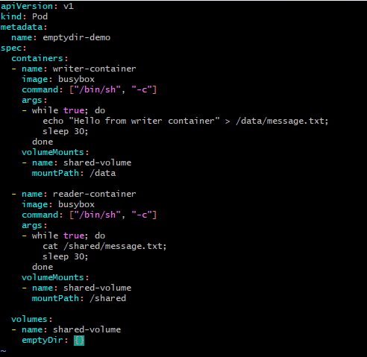

2)Deploy the pod
Kubectl apply -f emptydir.yaml
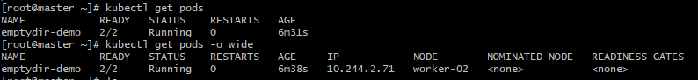

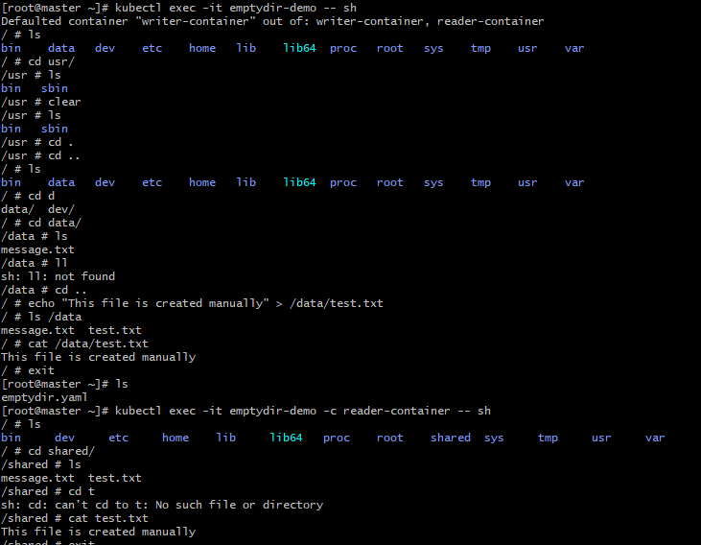

2.Configure a HostPath Volume in Kubernetes and Validate Data Persistence.
Steps:
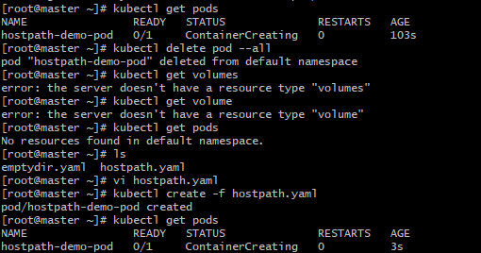
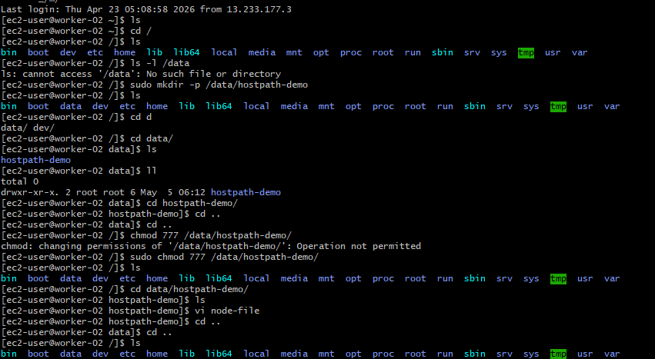
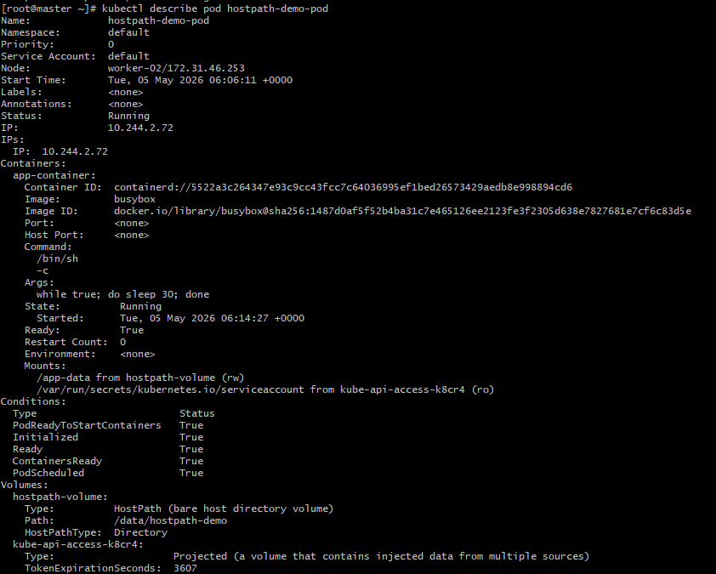
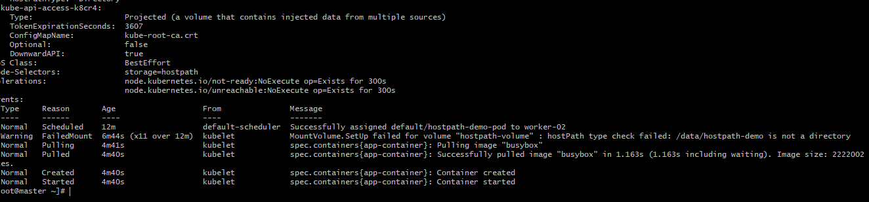

3.Deploy an Amazon EBS Volume Using Persistent Volume and Persistent Volume Claim (PVC)
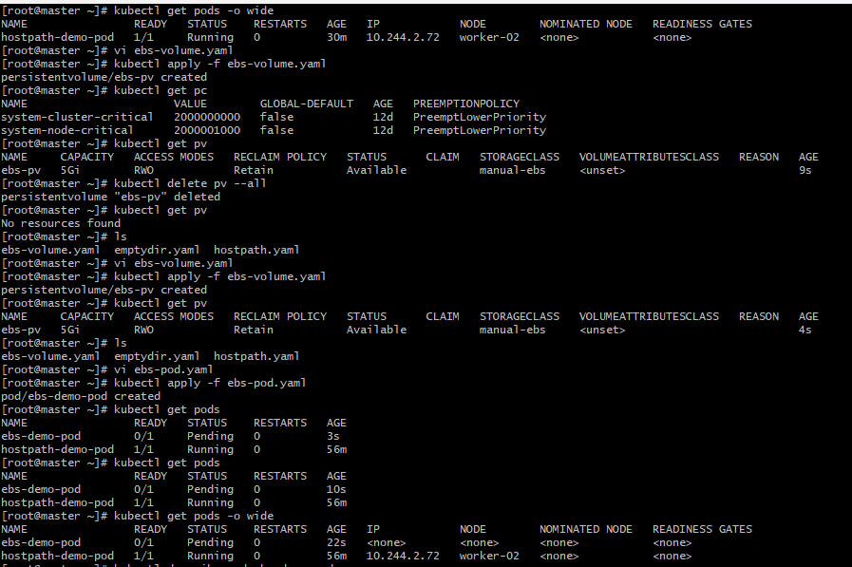

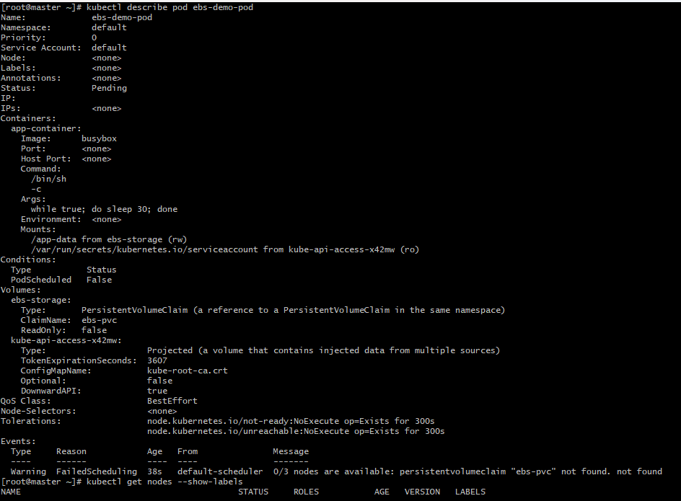

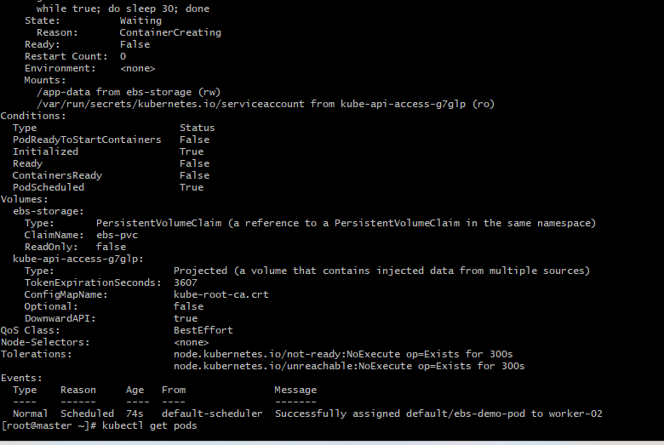

4.Set Up an Amazon EFS Volume and Attach it to Multiple Pods
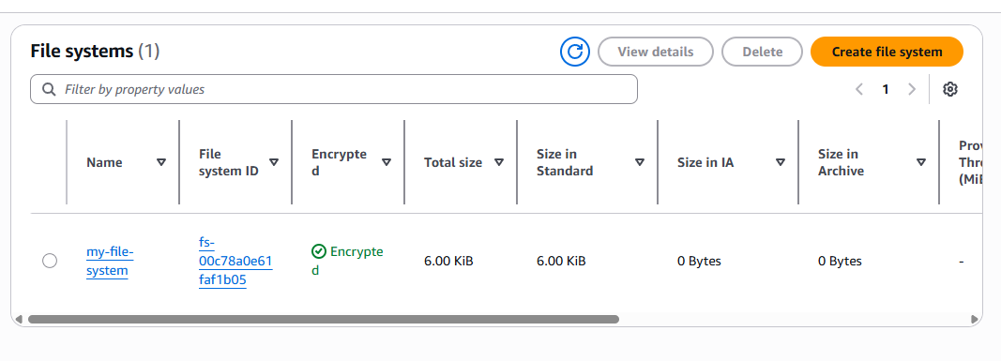

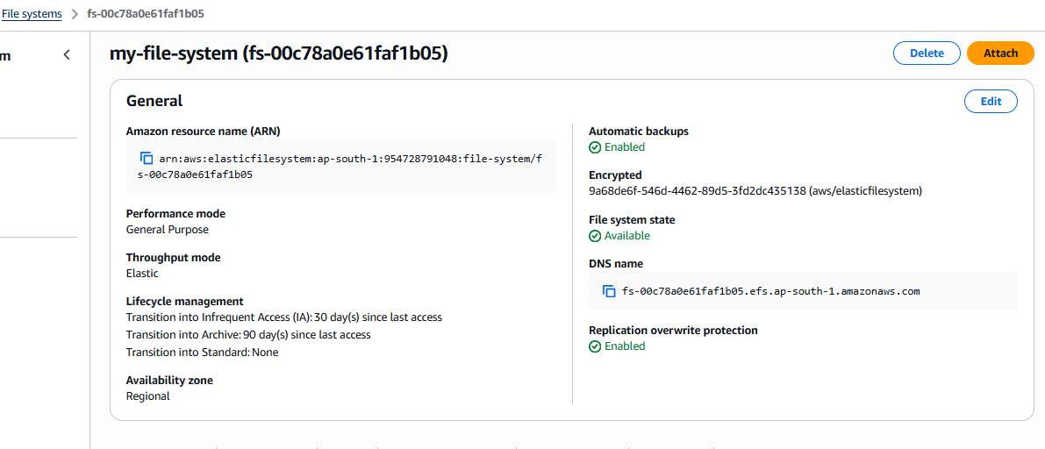
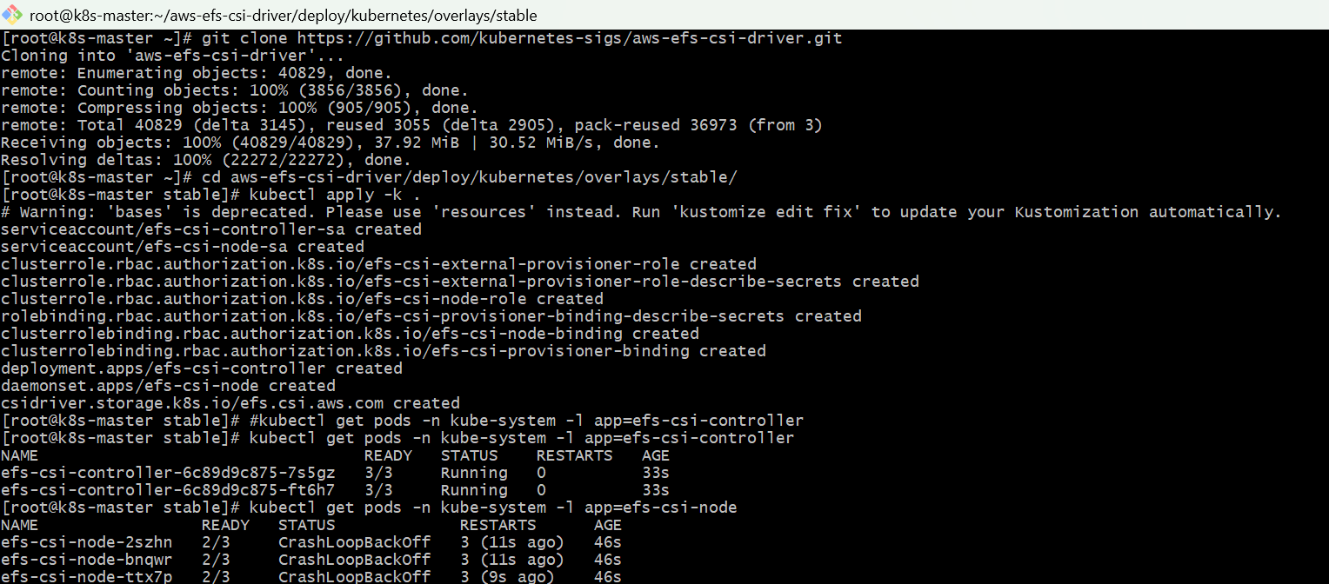

5.Implement and Test Liveness and Readiness Probes in a Kubernetes Pod

Steps:

- Create YAML file
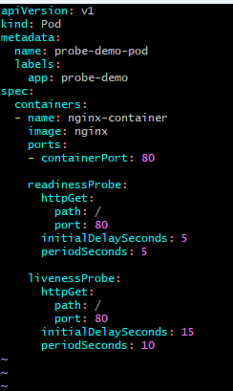

- Deploy the pod
Kubectl apply -f prob.yaml
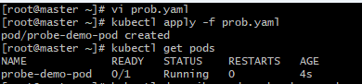

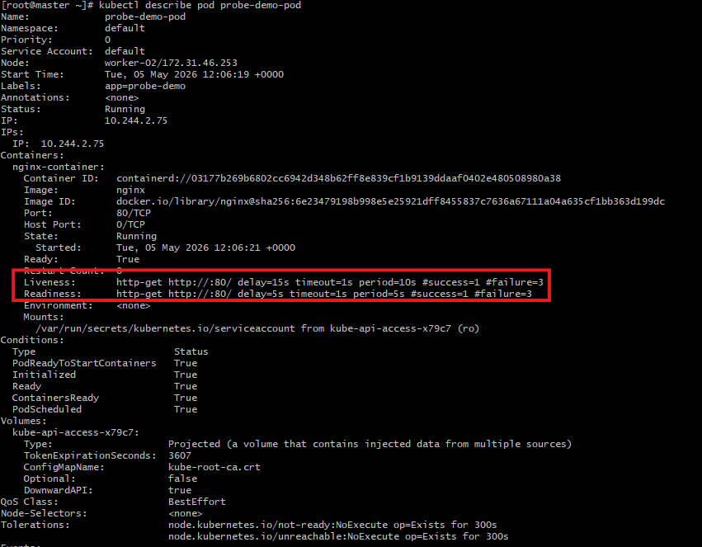

3) Create a Service
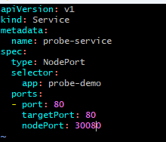
- Deploy the service
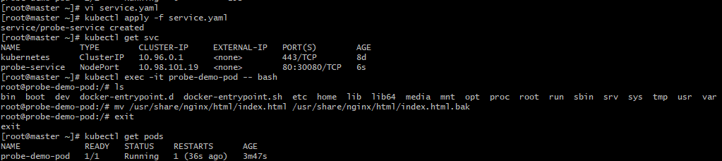

- Test application
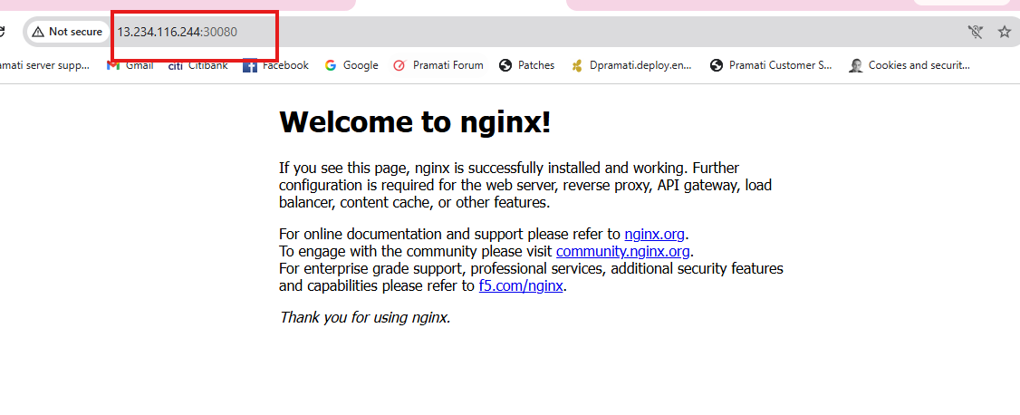

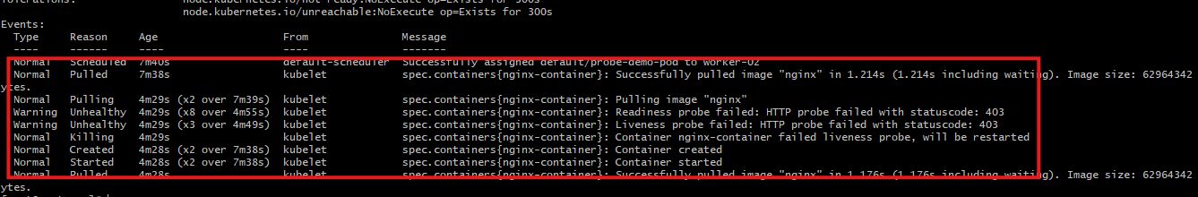
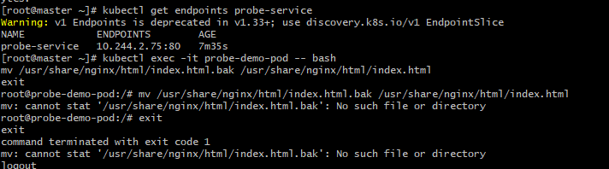
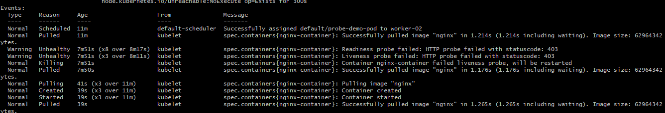

- Create and Test a Kubernetes Pod with an EmptyDir Volume.

Steps:

1) Create YAML file


2)Deploy the pod
Kubectl apply -f emptydir.yaml




2.Configure a HostPath Volume in Kubernetes and Validate Data Persistence.
Steps:





3.Deploy an Amazon EBS Volume Using Persistent Volume and Persistent Volume Claim (PVC)






4.Set Up an Amazon EFS Volume and Attach it to Multiple Pods





5.Implement and Test Liveness and Readiness Probes in a Kubernetes Pod

Steps:

- Create YAML file


- Deploy the pod
Kubectl apply -f prob.yaml




3) Create a Service

- Deploy the service


- Test application






v

